|  |
| --- |
|  |
| Echo Team Final Report |
|  |

|  |
| --- |
| Samuel Lewis, Victoria Herandez, Michael Maher, Layla Jaber, Kaliya Mackey  5-6-2025 |

Contents

Executive Summary 2

Work Completed 2

Gantt Chart 2

Research 2

Prototyping 3

Usability Testing 4

Flyer Design 4

Justification 4

Microsoft Bookings 4

Landing Page 5

Before and After 5

Lessons Learned 6

Samuel Lewis 6

Victoria Hernandez 6

Kaliya Mackey 7

Layla Jaber 7

Michael Maher 7

Project Suggestions 8

Team Roles and Contact Information 8

Appendix 9

Microsoft Bookings User Facing Page 10

Old Reservation System 10

Software Comparison Chart 11

Microsoft Bookings Admin Page 12

Project Schedule 12

Landing Page Wireframe 13

Live Landing Page 14

Flyer 15

Microsoft Booking Documentation 16

# Executive Summary

Our capstone project for this semester came from Amanda Charles, the budget and operations coordinator for the dean's office of Fisher College of Science and Mathematics. The focus of this project was on modernizing the room reservation system for the Huddle Room study spaces. These rooms are designed for small group collaboration and are equipped with four seats, a table, a mounted monitor, and other useful amenities. Previously, room reservations were managed using a pen-and-paper sign-up sheet, which was inefficient and prone to errors. Our primary goal was to replace this outdated system with a streamlined, electronic scheduling solution for student use.

In addition to the core reservation system, we were also tasked with integrating the existing Crestron scheduling panels installed outside each room. Under the old system, these panels were not being used. As part of our project, we configured them to display real-time room availability and automatically change status—from green to red—when a reservation begins. Finally, the system needed to provide administrative access for the client and other authorized users, allowing them to manage, modify, or cancel reservations as necessary.

# Work Completed

### Gantt Chart

The purpose of the Gantt chart is to assist in the planning and scheduling of tasks for the huddle room reservation project. This visual tool breaks down the project into distinct tasks, assigns deadlines, and establishes a clear timeline for the entire project. By mapping out each task and its duration, the Gantt chart provides a comprehensive overview of the project's progress, enabling the team to monitor the completion of both the overall project and individual tasks. The use of the Gantt chart enhanced communication among team members and ultimately helped keep the project on track.

### Research

When determining a solution our group researched multiple web-based solutions. After meeting with OTS to determine our options, we compared Microsoft Booking, Outlook Calendar, 25 Live and Google calendar. In order to pick the right one, we balanced the solutions between what would be best for our group and best for the university. We judged the solutions on the following criteria:

* Self-Service Booking
* Ease of Mangement
* Ease of Use
* Scalability
* Ease of Implementation
* Integration with existing software
* Cost

After determining which platform was optimal, we were recommended related software within Towson, which includes implementing the use of Cook library’s current booking software to assess requirements now featured in the Science Complex booking system. This includes the assumed outline for the database to store information on account, contact, and reservation information. While developing these expectations, we had to comply with the requirement to implement the Crestron panels which integrated with the Microsoft bookings software.

### Prototyping

The initial version of our Microsoft Bookings page featured a single page with eight reservation options. These included time slots in 30-minute intervals, up to 3 hours. Additionally, there were two longer options—2-hour and 3-hour reservations—specifically labeled for faculty and staff. The student options were designed to provide flexibility, with shorter durations like 30 minutes allowing for a higher number of reservations per day. For faculty and staff, our review of room calendars indicated that reservations shorter than 2 hours were uncommon. Even when the full time wasn’t used, overall traffic in those rooms remained lower than in student-designated spaces.

When we presented this prototype to Amanda Charles, she raised concerns that students might accidentally—or intentionally—book reservations in faculty rooms. She also recommended that the rules of use be added to the page to ensure students reviewed them before booking. Additionally, she requested that the maximum duration for student reservations be limited to 2 hours.

Taking that feedback into consideration, we revised our design. First, we created a separate Microsoft Bookings page specifically for faculty and staff rooms, eliminating the risk of students reserving those spaces. Next, after evaluating the remaining time in the semester, we decided to expand the project scope to include a landing page hosted by Towson University. This landing page would display the rules of use and provide a link to the appropriate bookings page, ensuring students are aware of the guidelines before proceeding. We also removed the options for reservation durations after 2 hours.

### Usability Testing

We conducted usability testing with two of our classmates to evaluate the usability of our system. They were asked to complete the following tasks:

* Schedule a reservation
* Reschedule a reservation
* Delete a reservation
* Attempt to break the system

We observed them throughout the testing process and found that both users experienced little to no difficulty completing the tasks. All attempts to break the system were unsuccessful, showing that the system is stable and reliable for users. Additionally, we asked them if there were any improvements they recommended that could improve our system. Most of the feedback we received pertained to features of Microsoft Bookings that could not be changed from our end of the system.

### Flyer Design

We designed an informational flyer to guide students on how to properly reserve and use the huddle rooms. The flyer has a list of rules to ensure proper use of the rooms by students. We also embedded a QR code that links directly to our landing page on the Towson University Fisher College website where students can access the bookings page and reserve a timeslot. The flyer was created using Microsoft Word and uses a similar format and color to the previous flyers used for the huddle rooms to avoid confusion from unfamiliarity. The QR was generated using Adobe Express and it was tested for usability to ensure an easy user experience.

# Justification

### Microsoft Bookings

Microsoft Bookings was selected for this project due to its seamless integration with Towson University’s existing Microsoft 365 infrastructure, including Outlook calendars. This compatibility made it an ideal choice for enabling real-time scheduling updates and ensuring consistent access control through university accounts. Bookings offered a low-maintenance, user-friendly interface for students while providing the administrative flexibility required by faculty and staff. Its ability to automate confirmations, prevent double-bookings, and synchronize with the Crestron scheduling panels allowed us to create a functional reservation system without the need for custom software development. This made Bookings both a practical and sustainable solution for the university’s needs.

### Landing Page

A dedicated landing page was implemented to serve as a central access point for the Huddle Room reservation system. Because separate Microsoft Bookings pages were created for students and faculty—each with different permissions and room access rules—the landing page simplified navigation by guiding users to the correct booking page based on their role. Hosting this page on the Towson University website also ensured credibility, visibility, and ease of access for all users. Additionally, the landing page included important usage guidelines and contact information, helping to reduce confusion and support requests while providing a more user-friendly experience overall.

# Before and After

Prior to our participation in this project, the huddle room reservation system relied on a manual paper sign-up sheet. The sign-up sheet would have to be replaced each week for students to reserve for timeslots for the week. This system lacked the ability to apply restrictions like placing a time limit on reservations and preventing double bookings. The Crestron panels outside of each room were not being utilized to display active reservation details. There was also no way to separate student and faculty reservations. Additionally, the previous system had no way of controlling what type of information the students wrote down. For example, in the email section of the sign-up sheet students would write down an either an email from outside of Towson University or whatever they felt like writing.

After our involvement and a few meetings with our client Amanda Charles, we were able to create a fully functional huddle room booking system using Microsoft Bookings. These bookings pages ensure proper access control and meet the client requirements. Our system includes two separate bookings pages, one for students and one for faculty. We also created a custom landing page with the rules for the rooms as requested by Ms. Charles. The landing page also allows for users to choose the appropriate booking page based on the status as a student or faculty. We also configured the Crestron panels to sync with Microsoft bookings, allowing the panels to update with real time reservations. Our team was able to successfully deliver a system that streamlined the functions of the previous while also simplifying functionality from an administrative point of view.

# Lessons Learned

### Samuel Lewis

One of the most valuable lessons I learned from this capstone project was the importance of clear communication. Although Amanda was a great client and supportive of our work, communication could sometimes be challenging due to her demanding role as Dean of the Fisher College. To her credit, she informed us early on that her schedule was extremely busy and encouraged us to follow up if we didn’t receive a response. While she was usually responsive, there were occasions where I had to follow up the next day. In one instance, I had to reach out to my professor after not receiving a response even after a follow-up. This experience taught me the value of being persistent and professional in communication and also to be patient with clients, but not so patient that it results in unnecessary project delays or lost time.

### Victoria Hernandez

One important lesson I learned while participating in this project would be to have an in-depth understanding of our clients' expectations before implementing any solutions. Early on in our project we a several meeting where Amanda explained her goals for the final system. These meetings were extremely valuable when beginning our research into possible solutions. This prevented time wasting and allowed us to find a viable solution early on, giving us more time to develop and implement our system. Getting an in-depth understanding early on also allowed us to reach out to people more knowledgeable about these systems.

Another valuable lesson that I learned from participating in this project is the importance of pivoting when faced with a challenge. After our first meeting with Amanda, we learned that she wanted us to find a way to restrict access to different rooms between students and faculty. The original solution we came up with was to use the Microsoft bookings system to figure out a way to set permissions that restrict access for certain rooms. We tried to use an application that is integrated with Microsoft booking called Power Automate. After this method failed, we quickly pivoted to another option which would include creating two separate bookings pages for students and faculty, as well as creating a landing page to hold links to both of the pages. We pivoted to these solutions quickly, ensuring that we stayed with our timeline for the project as well meeting the requirements given to us by Amanda.

### Kaliya Mackey

The most valuable lessons I learned during this capstone project was recording every aspect of the development process is a critical task when ensuring proper implementation of the scope. Thanks to Amanda’s clear description, OTF guidance, and my teams amazing collaborative efforts, I was able to improve my understanding that different perspectives of visions require comprehension. This is critical because it requires listening to comprehend to initiate the development process for managing staying within scope.

### Layla Jaber

Throughout this project, I gained several valuable lessons that I believe will greatly benefit my professional career. Firstly, I learned just how crucial it is to consider your audience and understand their perspective while speaking/presenting. I also learned how useful visual aids, such as charts, are in simplifying complex information and making it easier to understand for a wider range of people. Additionally, I witnessed firsthand the importance of having a clear, up-to-date schedule to keep our team on track. Finally, I realized how vital it is for everyone on the team to share a common understanding of our goals and tasks. Regular check-ins helped to eliminate confusion and ensured that our work continued to progress smoothly.

These interpersonal skills, beyond just technical knowledge, were what really made our project successful and helped reinforce everything I’ve been learning in my previous classes.

### Michael Maher

During this project I learned multiple lessons, All of which will impact how I approach projects in my future career. One of these lessons is learning how to use your network and resources to advance your goals. The insight and advice we gained from working with OTS and the Tech Help desk was crucial to the success of our project. Another great lesson I learned was to have effective communication. As a team we discussed ideas as a whole and made sure everyone’s voice was heard. Finally, a major lesson learned was the importance of adaptability. From learning how to enforce system requirements on a system that wasn't designed for our exact requirements, to creating a landing page late in the schedule, it was important to be able to respond effectively to complete our project. I know these lessons will be useful in the professional world.

# Project Suggestions

To further strengthen the reservation system, automated policy enforcement should be integrated directly into the booking workflow. By requiring users to acknowledge and confirm relevant policies through pop-ups or checkboxes before booking confirmation, the system can ensure greater compliance and foster increased user accountability.

Additionally, enhanced access controls are recommended through deeper integration between the Crestron room scheduler and existing access control systems. This would enable seamless, real-time room entry and monitoring, ensuring that only users with validated bookings are granted access. Such measures would significantly improve overall security and reduce unauthorized room usage.

Comprehensive usage reporting is also essential for effective resource management. The development of administrative dashboards would provide actionable insights into room utilization patterns, peak usage periods, and instances of access violations. These metrics would empower administrators to make data-driven decisions and optimize the allocation of resources across the facility.

# Team Roles and Contact Information

**Samuel Lewis** – Team Leader, Single Point of Contact, Developer, Web Designer

Email: [samlewis1226@gmail.com](mailto:samlewis1226@gmail.com)

**Kaliya Mackey** – UX Director, Developer, Designer

Email: [kaliyamackey@gmail.com](mailto:kaliyamackey@gmail.com)

**Victoria Hernandez** – Research, Developer, Flyer Designer

Email: [victoriahernandez.contact@gmail.com](mailto:victoriahernandez.contact@gmail.com)

**Layla Jaber** – Project manager, Developer, Archivist, Presentation Design

Email: [laylamjaber1@gmail.com](mailto:laylamjaber1@gmail.com)

**Michael Maher** – Developer, Designer, Research

Email: [mikemaher914@gmail.com](mailto:mikemaher914@gmail.com)

# Appendix

### Microsoft Bookings User Facing Page

### Old Reservation System

### Software Comparison Chart

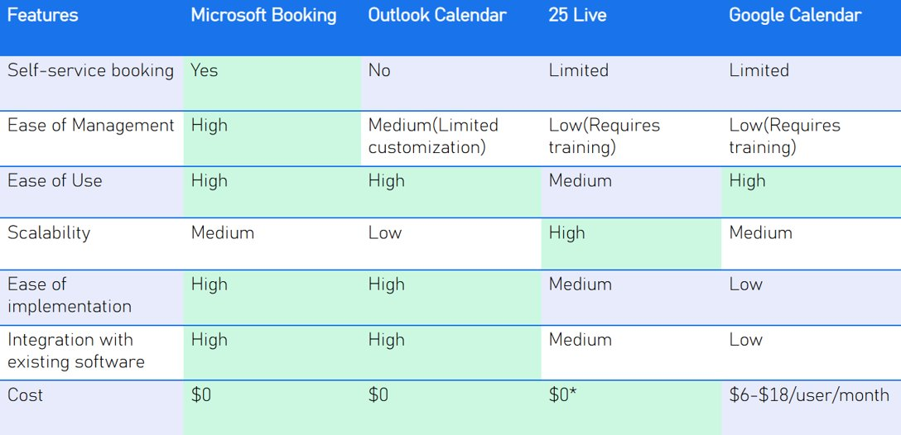

### Microsoft Bookings Admin Page

### Project Schedule

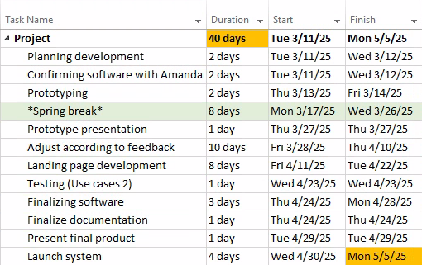

### Landing Page Wireframe

### Live Landing Page

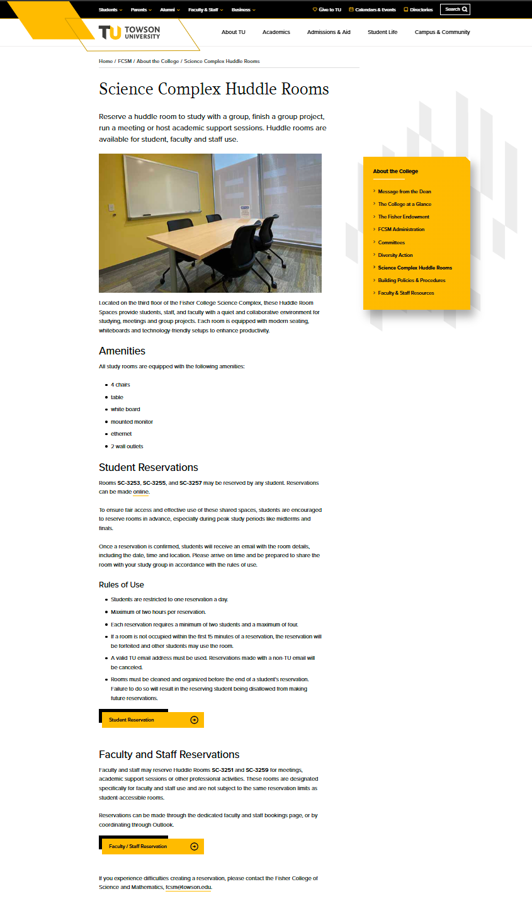

### Flyer

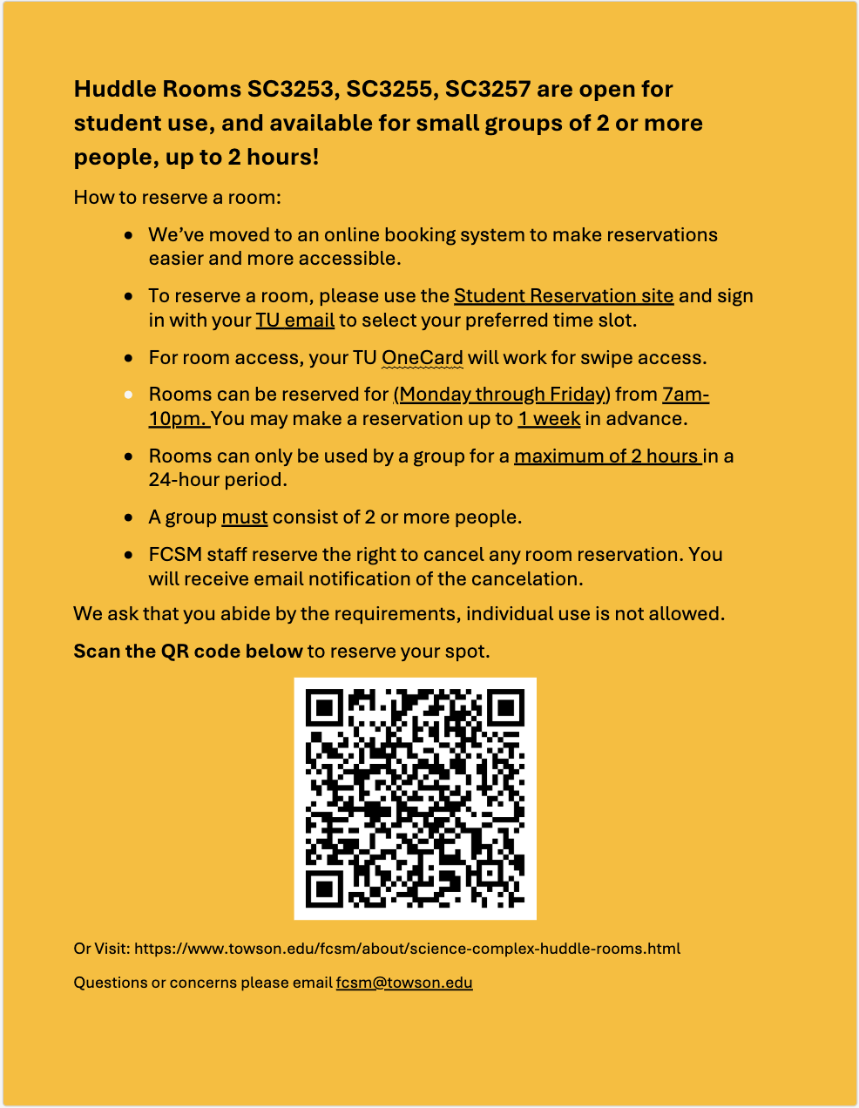

### Microsoft Booking Documentation

Accessing the Admin Page

To manage the Bookings page for the *Science Complex Huddle Rooms*, follow the steps below:

Step 1: Log into Office 365

1. Go to [office.com](https://www.office.com/) and sign in with your TU account.

Step 2: Open Microsoft Bookings

1. Click the **App Launcher** (the 9-dot grid in the top-left corner of the page).
2. Look for **Bookings** in the app list.
3. If it is not visible, click **“All apps”** or **“More apps”** to view the full list of available applications.
4. Select **Bookings** from the list.

Step 3: Access the Admin View

1. Once in the Bookings dashboard, locate the **Shared Bookings Pages** section.

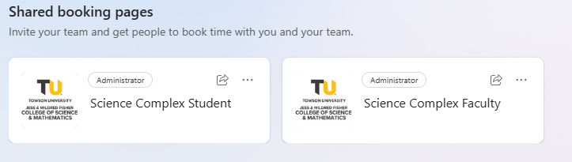

1. If you have administrative access, you should see the relevant pages listed here.
2. Look for:
3. **Science Complex Student Huddle Rooms**
4. **Science Complex Faculty and Staff Huddle Room**
5. If the page is not listed, use the **Search** bar within the Bookings dashboard to search by name.
6. If the page still does not appear after searching, it is likely that you do not have admin privileges for that specific booking calendar.

Note

* Only users with administrative permissions will be able to manage the bookings page, including settings, staff assignments, and calendar availability.
* If you believe you should have access, contact the Office of Technology Services through the TechHelp portal.

Edit Room Name, Hours, and Availability

To **change the display name, business hours, or manually set availability for a room**, follow these steps:

Change Room Name and Manual Availability

1. Open **Microsoft Bookings** and navigate to the desired Bookingspage.
2. In the left-hand navigation panel, click **Staff**.

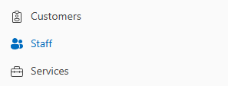

1. Locate the room you want to modify. Each room is listed as a "staff member" (for example, "FCSM - SC3253").

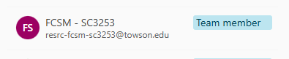

1. Click the pencil icon next to the room name to edit staff details.

, Picture

From here, you can:

* **Adjust Availability**: Scroll down to the **Availability** section.
* Select **“Use business hours”** to keep default availability.

, Picture

* Or choose **“Set different availability for this staff”** to define specific days and times the room is available for booking (e.g., Monday to Thursday, 9 AM – 4 PM).

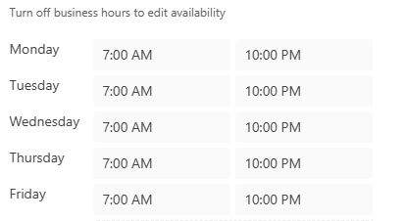

When done, click **Save** to apply your changes.

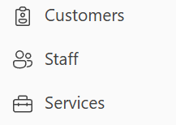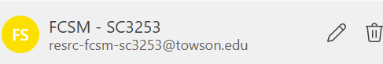

Modifying Lead Time, Time Increments, and Service Duration

To customize how users can book appointments—such as how far in advance they can schedule, appointment duration, and buffer time—follow the steps below.

Change Lead Time, Buffer Time, and Time Increments

1. In **Microsoft Bookings**, go to the **Science Complex Huddle** page.
2. Click **Services** from the left-hand panel.
3. Select the appropriate room listing (e.g., "Huddle Room – 1 hour 30 minutes") and click **Edit Service**.

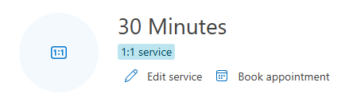

1. Scroll to the **Scheduling Policy** section.

, Picture

In this section, you can:

* **Set Default Duration**: Change how long each appointment lasts (e.g., 90 minutes).
* **Add Buffer Time**: Add extra time before or after each appointment to avoid overlap and allow for transition or preparation.
* **Set Minimum Lead Time**: Choose how far in advance a booking must be made (e.g., 1 hour, 24 hours).
* **Set Maximum Lead Time**: Determine how far into the future a user can book an appointment (e.g., up to 30 days in advance).
* **Adjust Time Increments**: Choose how often appointment slots appear (e.g., every 30 minutes, every hour).

Click **Save** to confirm your changes when finished.

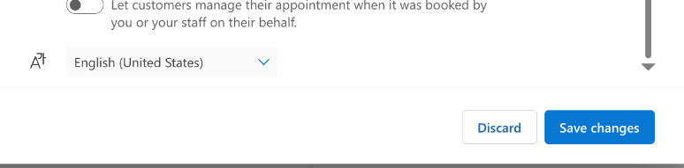

Blocking Off Room Availability

If you need to temporarily prevent a room from being booked—for example, during maintenance, meetings, or closures—you can easily do this from the Bookings calendar by adding Time Off directly.

This method is quick and convenient for one-time or short-term closures.

Step 1: Open the Microsoft Bookings Calendar

1. Go to Microsoft Bookings via Office 365.
2. Select the correct Bookings calendar (e.g., *Science Complex Student Huddle Rooms* or *Science Complex Faculty and Staff Huddle Room*).
3. In the left-hand navigation panel, click Calendar.

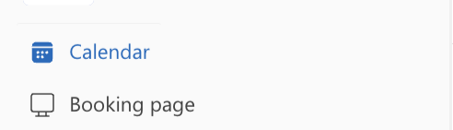

Step 2: Choose the Room Calendar

1. In the top-left corner of the calendar, make sure the room you want to block (listed as a staff member) is selected.
2. If needed, use the dropdown to filter and display a specific room’s calendar.

Step 3: Add Time Off

1. Navigate to the date you want to block off.
2. Click the “Add Time off” button at the top of the calendar view.

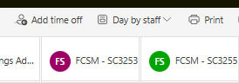

1. A form will appear for you to create the time-off entry.

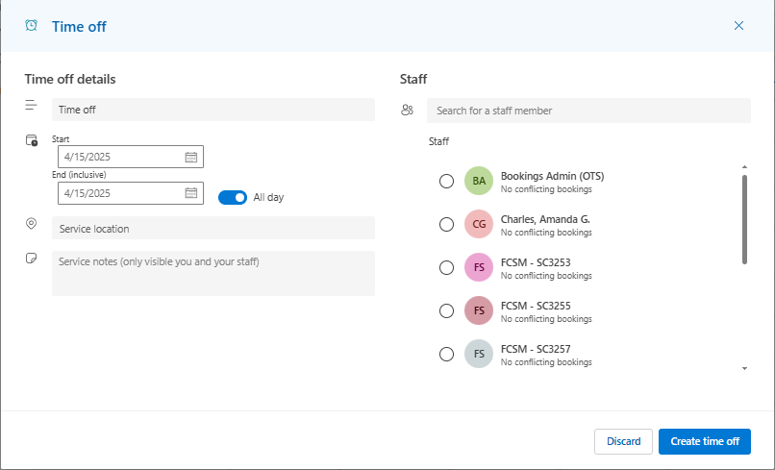

Step 4: Fill Out the Time Off Form

1. Staff Member: Select the room to block (e.g., “FCSM - SC3253”).
2. Title (Optional): Add a short description (e.g., “Room Unavailable” or “Cleaning/Maintenance”).
3. Date and Time:

* Set the start date/time and end date/time.
* Or, enable “All day” if the room will be unavailable the entire day.

1. Repeat (Optional): If this is a recurring block (e.g., every Monday), configure the repeat settings as needed.

Step 5: Save the Time Off Entry   
Click Save to confirm. The room will now appear as unavailable during the selected time and will not be bookable.

Notes:

* You can edit or delete time-off blocks by clicking on them directly in the calendar.
* This does not permanently affect the room’s general availability—normal hours resume after the blocked time ends.
* Only administrators can add or manage time-off entries.

How to Add a New Room

In Microsoft Bookings, each room must be added as a **staff member** in order to manage its availability and allow users to book it. Rooms should be added using a standardized naming convention to ensure they are recognized in the directory.

Step 1: Open the Bookings Page

1. Sign into Office 365 and open **Microsoft Bookings**.
2. Select the appropriate Bookings calendar (e.g., *Science Complex Student Huddle Rooms*).

Step 2: Go to the Staff Section

1. In the left-hand menu, click **Staff**.

Picture 358869030, Picture

Step 3: Add a New Staff Member (Room)

1. Click the **“+ Add staff”** button at the top.

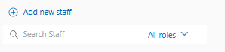

1. In the **Name** field, enter the room name using the required format:   
   **FCSM – SC####** (e.g., *FCSM – SC3253*).
2. This naming format is necessary so the room can be found in the organization’s Outlook directory.

, Picture

1. In the **Email** field, use the Outlook resource mailbox address associated with the room.
2. If you are unsure of the room’s mailbox address, contact OTS or your administrator.
3. Under **Availability**, select one of the following:
4. “Use business hours” to apply the default calendar’s availability.
5. “Set different availability” to customize the room’s booking hours.

, Picture

1. Uncheck “Events on Office calendar affect availability” if the room is not linked to a personal calendar and only exists as a resource.

Step 4: Save the Staff Member   
Click **Save** to finalize. The room will now appear as a selectable option under available staff/services when creating or editing a service.

How to Add or Remove Admins

Admins in Microsoft Bookings have full permissions to manage services, staff (rooms), scheduling policies, and view booking activity. Only users with a **Towson University (TU) email address** can be added as admins.

Step 1: Go to the Staff Section

1. Open **Microsoft Bookings**.
2. Select the appropriate Bookings calendar (e.g., *Science Complex Student Huddle Rooms* or *Faculty and Staff Huddle Rooms*).
3. In the left-hand menu, click **Staff**.

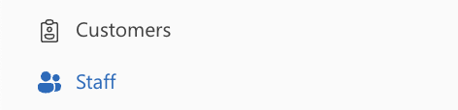

Step 2: Add a New Admin

1. Click **“+ Add staff”**.

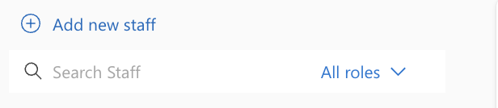

1. In the **Name** field, enter the name using the format:   
   **[Last Name], [First Name]** (e.g., *Smith, John*).
2. This format ensures the name appears correctly and is searchable in the directory.
3. In the **Email** field, enter the person’s **Towson University email address** (e.g., jsmith@towson.edu).
4. Under **Role**, select **Administrator**.
5. Click **Save**.

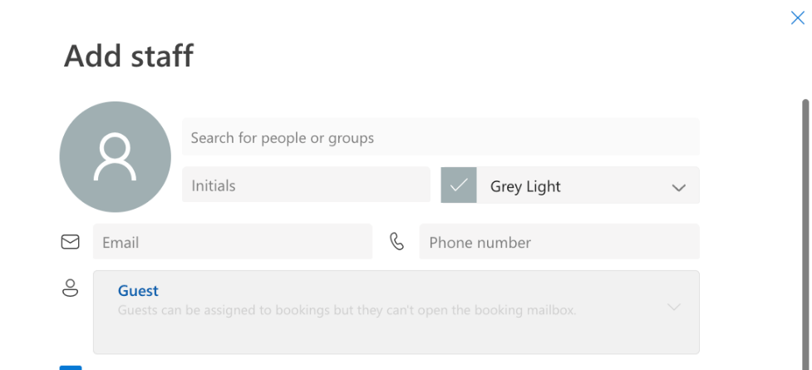

Step 3: Change an Existing User’s Role to Admin

1. In the **Staff** list, click the name of the person whose role you want to change.
2. Under the **Role** dropdown, select **Administrator**.
3. Click **Save**.

Step 4: Remove an Admin or Staff Member

1. In the **Staff** section, find the person you want to remove.
2. Click on their name to open their profile.
3. Click the **trash can icon** in the top-right corner of their profile.
4. Confirm deletion when prompted.

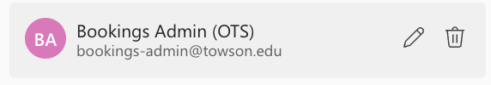

**Note:** Only users already designated as administrators can add or remove other staff members or change roles.

How to Reassign an Appointment from "No Staff Assigned"

What Does "No Staff Assigned" Mean?

In Microsoft Bookings, an appointment may show up as **“No staff assigned”** if it was created without a specific staff member (or room) selected. This often happens due to one of the following reasons:

* A **staff member (room) was removed** or marked unavailable **after** the appointment was made.
* The **staff assignment failed** due to conflicting availability or a calendar syncing issue.
* The booking was **created manually** and the staff field was left blank.

When this occurs, the appointment won’t appear under any specific room’s schedule and must be reassigned manually.

Step 1: Open the Bookings Calendar

1. Log in to **Microsoft Bookings**.
2. Select the appropriate calendar (e.g., *Science Complex Student Huddle Rooms*).
3. Click **Calendar** in the left-hand navigation panel.

Step 2: Find the Appointment

1. Browse to the date of the affected appointment.
2. Locate the booking that shows **“No staff assigned”**—it may appear as a grey box.
3. Click on it to open the booking details.

Step 3: Edit the Appointment

1. In the pop-up or detail panel, click **Edit**.
2. Locate the **Staff** field—it should currently say “No staff assigned.”

Step 4: Reassign to a Room (Staff Member)

1. Click the dropdown menu under **Staff**.
2. Select the appropriate room/staff member from the list (e.g., *FCSM – SC3251*).
3. If no staff appear, verify that:
4. The room is available at that time.
5. The room is assigned to the service.
6. The room has not been marked as “Time Off” or made inactive.

Step 5: Save the Appointment

1. Once the staff member is selected, scroll down and click **Save**.
2. The booking will now appear correctly under that room’s schedule on the calendar.

Important Notes:

* You must have **Administrator privileges** on the Bookings page to edit and reassign appointments.
* To prevent this issue, double-check that each service has properly assigned staff and that all rooms are kept active and available during normal hours.
* You can also disable the ability to book without staff by editing the service settings and turning on “**Let customers choose a specific staff member**.”

How to Update the Bookings Page Name, Hours, and Logo

The **Business Information** tab in Microsoft Bookings controls how your booking page is displayed to users. Below are the steps to update the **Business Name**, **Business Hours**, and **Logo**.

Step 1: Open Microsoft Bookings

1. Sign into your Office 365 account at [office.com](https://www.office.com/).
2. Launch **Microsoft Bookings** from the app launcher.
3. Select the appropriate calendar (e.g., *Science Complex Student Huddle Rooms*).

Step 2: Navigate to Business Information

1. In the left-hand menu, click on **Business Information**.

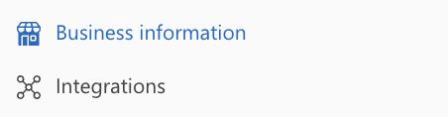

Step 3: Update the Business Name

1. At the top of the page, locate the **Business name** field.
2. Enter the name you want displayed on the public booking page.
3. Example: *Science Complex Student Room Reservations*

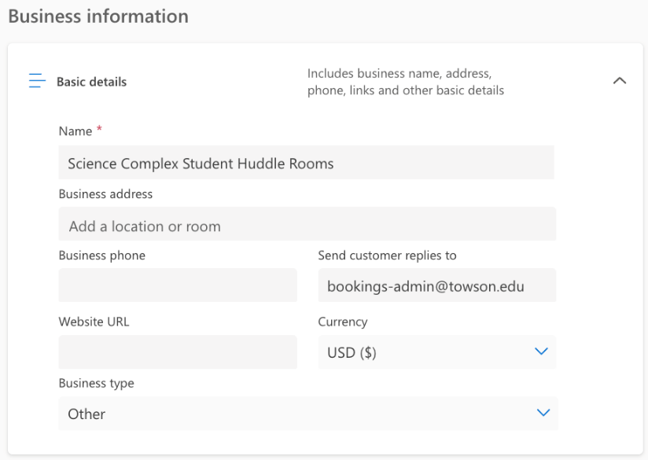

Step 4: Edit Business Hours

1. Scroll down to the **Business hours** section.
2. For each day of the week, use the dropdowns to set the room availability hours.
3. You can also mark a day as **Closed** if the rooms aren’t available on that day.
4. These hours act as the default availability for all rooms set to “Use business hours.”
5. You can add multiple time ranges for the same day if needed (e.g., open 9 AM–12 PM, break, then 1 PM–5 PM).

, Picture

Step 5: Change the Logo

1. Scroll to the **Business logo** section near the bottom of the page.
2. Click **Change logo** or **Upload image**.
3. Select an image file from your computer and confirm.
4. Recommended format: PNG or JPG
5. Choose a high-quality logo with a transparent or clean background for best appearance on the booking page.

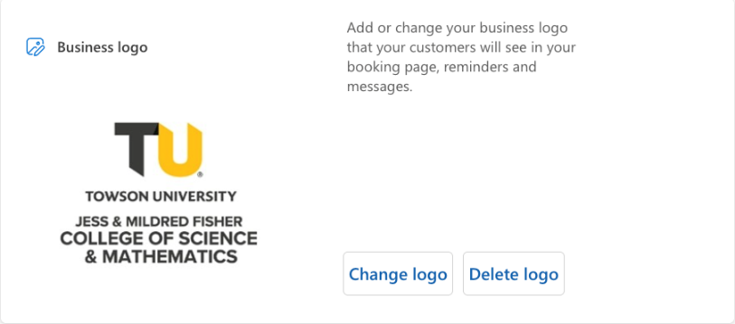

Step 6: Save Your Changes

1. Once all edits are complete, scroll to the top or bottom of the page.
2. Click **Save**.

Notes:

* The **Business Name** appears as the header on your public booking site.
* **Business Hours** apply by default to any room set to “Use business hours” under their staff settings.
* The **Logo** is displayed in the header of your booking page and helps visually brand your reservation system.

How to Change the Page Template and Color Theme

Microsoft Bookings allows you to customize the **look and feel** of your public-facing booking page by modifying the **template style and color scheme**.

Step 1: Open Microsoft Bookings

1. Go to [office.com](https://www.office.com/) and sign in with your Towson University credentials.
2. Open **Microsoft Bookings** from the App Launcher (9-dot grid).
3. Select the correct Bookings calendar (e.g., *Science Complex Student Huddle Rooms*).

Step 2: Navigate to Booking Page Settings

1. In the left-hand menu, click on **Booking page**.

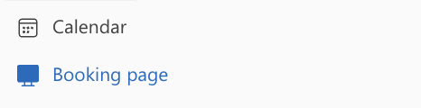

1. This section contains all the options for customizing your public booking site.

Step 3: Change the Page Template (Layout Style)

1. Scroll down until you see the **Template layout** section.
2. Choose from the available layout styles:
3. **Tabbed layout** (modern and clean, recommended)
4. **List layout** (more compact view of services)
5. Select the layout that best fits your booking needs and audience.

Step 4: Choose a Color Theme

1. Look for the **Color theme** section on the same page.
2. Click the color palette dropdown to select a predefined theme:
3. Blue, Green, Purple, Orange, Gray, and others.
4. The preview will update automatically to reflect the color changes.

Step 5: Preview and Save

1. Use the **Preview Booking Page** link at the top of the page to see how your changes will look to end users.
2. Once satisfied, scroll to the top or bottom of the page and click **Save**.

Notes:

* Changes apply immediately to the live public booking page.
* The color theme affects headers, buttons, and highlights.

How to Create a New Microsoft Bookings Page

Microsoft Bookings pages must be created by Towson University’s Office of Technology Services (OTS). To request a new Bookings page, you will need to **submit a support ticket through TechHelp**.

Step 1: Open the TechHelp Portal

1. Go to the [**TechHelp**](http://techhelp.towson.edu/) website: techhelp.towson.edu
2. On the homepage, click **Open a Ticket**.

Step 2: Select the Appropriate Service Category

1. On the **Service Catalog** screen, scroll down and select:   
   **Email, Collaboration, Phones & eFax**

Step 3: Select Microsoft Outlook

1. Since Microsoft Bookings is part of the Outlook platform, click on:   
   **Microsoft Outlook**

Step 4: Open a Ticket

1. On the Microsoft Outlook service page, click **Open a Ticket** again.

Step 5: Complete the Ticket Form

1. Fill out the required fields on the form.
2. Be specific in your request (e.g., "Requesting a new Microsoft Bookings page for Science Complex Huddle Rooms").
3. Include any relevant details such as calendar owners, desired name of the page, or departments involved.
4. When finished, click **Submit**.

Notes:

* Once submitted, you will receive a confirmation email with a ticket number.
* A staff member from OTS will reach out if more information is needed.
* Only OTS can create or delete Bookings pages—administrators can manage them afterward but not create them.

How to Export Microsoft Bookings Calendar to Excel

Exporting your Microsoft Bookings calendar can be useful for auditing purposes or to support administrative decisions. For example, the data can help identify high-traffic time slots, track room usage trends, and justify the need for additional room availability.

**Step 1: Open Microsoft Bookings**

1. Go to [https://book.ms](https://book.ms/) and sign in with your Towson University credentials.
2. Select the specific Microsoft Bookings page you'd like to export data from.

**Step 2: Navigate to the Calendar or Bookings Tab**

1. On the left-hand menu, click on **Calendar** or **Bookings** to view scheduled appointments.

**Step 3: Click the Export Button**

1. In the top-right corner of the calendar view, click the **Export** button.

**Step 4: Select a Date Range**

1. When prompted, choose a **start date** and **end date** for the data you want to export.
2. Click **Export** or **Download** to generate the file.

**Step 5: Open the File in Excel**

1. The file will download as a .tsv (tab-separated values) file.
2. Double-click to open in Excel. Each column will represent a field such as:

* Name and email
* Staff assigned
* Appointment date and time
* Service
* Location
* Notes
* Booking status

Note:

* Microsoft Bookings only retains data for up to **120 days**. Export your data regularly if long-term records are needed.
* Exports are downloaded as **.tsv (tab-separated values)** files, which can be opened and analyzed in Excel.

Future Implementations References

* Brain Raley -> Technical experience with Crestron touch scheduling panel.

<https://www.towson.edu/technology/facultystaff/support/instruction/classroom/documents/cclt-fy18-annualreport.pdf>

* Crestron User guide for integration as a valuable solution for scheduling and managing meeting rooms effectively.

<https://www.crestron.com/getmedia/3b8b822e-fc7b-4609-a8d8-667aec51f3cb/mg_ug_crestron_fusion_software_add-in_outlook>

Additional Notes

* There is an account linked to both Bookings pages named “Bookings Admin (OTS)”, DO NOT remove this account. This account is managed by the Office of Technology Services and is used to perform maintenance and troubleshooting on the Bookings page.
* For additional assistance, Colin Levi for the Office of Technology Serivices has experience in setting up and maintaining Microsoft Bookings pages and should be able to assist you. He can be contacted at [mlevi@towson.edu](mailto:mlevi@towson.edu).